Name: ____________________________ Date:_______________
T: Which Material is best for different objects?
Look at the picture of an object. What material is it made from?
Think of a property for that material and a reason why the object has been made from it.
Task 1: Complete the sentences below (the first one has been done for you)
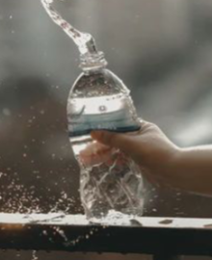 | The bottle is made from plastic.  It is transparent so that I can see what is inside it.
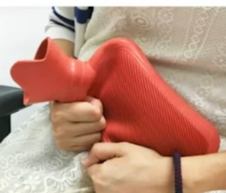 | The hot water bottle is made from _______________  It is _____________________so that _____________  __________________________________
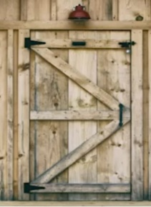 | The door is made from ______________  It is _______________________ so that ___________  ___________________________________

Task 2 – Complete these sentences
To make a table I would use _______________________ because it is
______________________________________________

To make a car I would use _______________________ because it is
______________________________________________

To make a jumper I would use _______________________ because it is
______________________________________________

